**Sales Dashboard**

**Objective:**

To contribute to the success of a business by utilizing data analysis techniques, specifically focusing on time series analysis, to provide valuable insights and accurate sales forecasting.

**Description:**

1. **Dashboard Creation**: Identified the KPIs, designed an intuitive and visually appealing dashboard and added interactive visualizations and filtering capabilities to allow users to explore the data at various levels of granularity.
2. **Data Analysis**: Provided valuable insights to business entities regarding the effectiveness of their sales strategies through visualization and charts.
3. **Sales Forecasting**: Leverage historic data and applied time series analysis to generate sales forecast for next 15 days.
4. **Actionable Insights and Recommendations**: End goal is to share valuable insights and actionable information that can drive strategic decision-making and support the super store's goals for growth, efficiency, and customer satisfaction.

**Project Insights and Recommendations:**

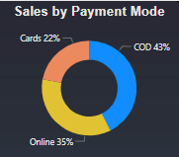

* From the chart we can see that highest mode of payment is COD followed by Online mode and Cards. Store can deep dive into the cards which are used for purchase and can give some offers to increase the sales.

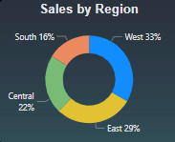

* The chart shows that the highest sales occurred in the West region followed by East and Central regions. The store can concentrate on the Western region more and dive deeper into countries of the region to come up with the strategies to maximize sales in these countries along with Eastern and Central region.

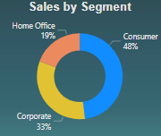

* We can conclude that highest sales occurs in Consumer segment followed by Corporate and Home Office Segment. The store can focus more on the Consumer segment and dive deeper into the countries to which these consumers belong to maximize the sales in those regions.

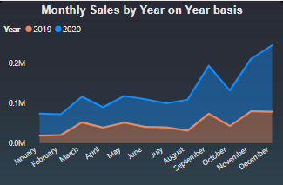

* The first 8 months had stable sales with an average of $98256.
* We had a significant increase in sales from September with the sales going up at in November.
* The sales increase from August to December shows how seasonality affects the Super Store sales.

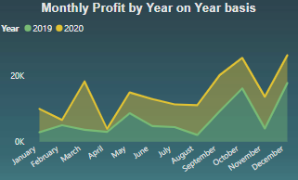

* The first 8 months had stable profit with an average of $11169.
* We had a significant increase in profits from September with the profit going up at in November.
* The profit increase from August to December shows how seasonality affects the Super Store sales.

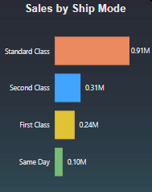

* We can see that people mostly preferred Standard class shipping mode and few people choose Same Day mode.
* The store can give some offers so that people can go towards First Class and Same Day shipping mode.

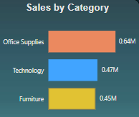

* The graph reveals that majority of sales occurred in the Office Supplies category followed by Technology and Furniture.
* The store can deep dive into the sub-categories of Office Supplies which are helping in increased sales and give some offers to those goods to further increase the sales.

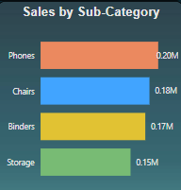

* We can conclude that the Phones sub-category is helping to increase sales of Technology category and Chairs and Binders to increase the sales of Office Supplies.

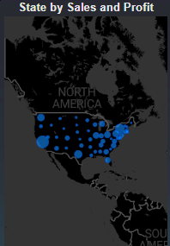

* The map shows that the majority of sales occur in Western region of the country, with only small amount in Southern and Northern.
* The company can concentrate on the Western market more and dive deeper into cities of the region to come up with the strategies to maximize sales in these cities along with Eastern and Central region.

**Learning:**

Incorporated data analysis techniques, specializing in time series analysis, to deliver valuable insights, accurate sales forecasting, and interactive dashboard creation, driving business success.